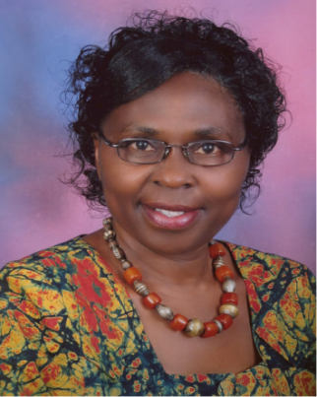
CDAIS International Forum held on 13-14 May 2019, at Agri-Bio Tech in the University of Liege, Gembloux, Belgium.
Prof. Florence Olubayo with her collaborators Prof. Robyn McConchie and Ms. Emma Walters from the University of Sydney, have been running a capacity building program on ‘increasing the development impact of Agricultural Research’ for mid-career Agricultural personnel in the African continent here in Kenya since 2015. A training program that builds the capacity of the trainees in soft skills, the use of stakeholder engagement and innovation platforms in passing on their research findings to the communities .The team got an opportunity to attend the CDAIS (Capacity Development in Agricultural innovation Systems) International forum which was held in Belgium in May 2019.

CDAIS, a project funded by the EU and implemented by AGRINATURA and FAO, is a global partnership in strengthening innovation capacities in Agriculture that has run for the last 4 years. The project operated in 8pilot countries; Angola, Burkina Faso, Ethiopia, Rwanda, Bangladesh, Guatemala, Honduras and Laos. They came together under the theme ‘Sharing and Shaping a Better Future, Catalysing agricultural innovation through strengthening functional capacities, or soft skills’. The forum served as a closure meeting of the project, where team members from the eight CDAIS countries, global co-ordination and other initiatives working on strengthening capacities to innovate in agriculture in developing countries shared insights and perspectives on this important process in Agricultural development. Real experiences from those involved in the eight countries presented a clear picture of increased transformations based on the integrated approach to strengthening functional capacities to innovate in agriculture. They demonstrated that changes had occurred; mindsets and attitudes had positively shifted.

For our team, this presented a learning, sharing and networking opportunity. We were able to interact and network with people engaged in similar activities focusing on improvement of the impact of agricultural research in the developing countries. The lessons learned will be useful in the delivery our upcoming training session.

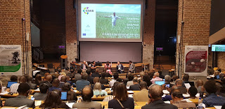
Forum in progress

