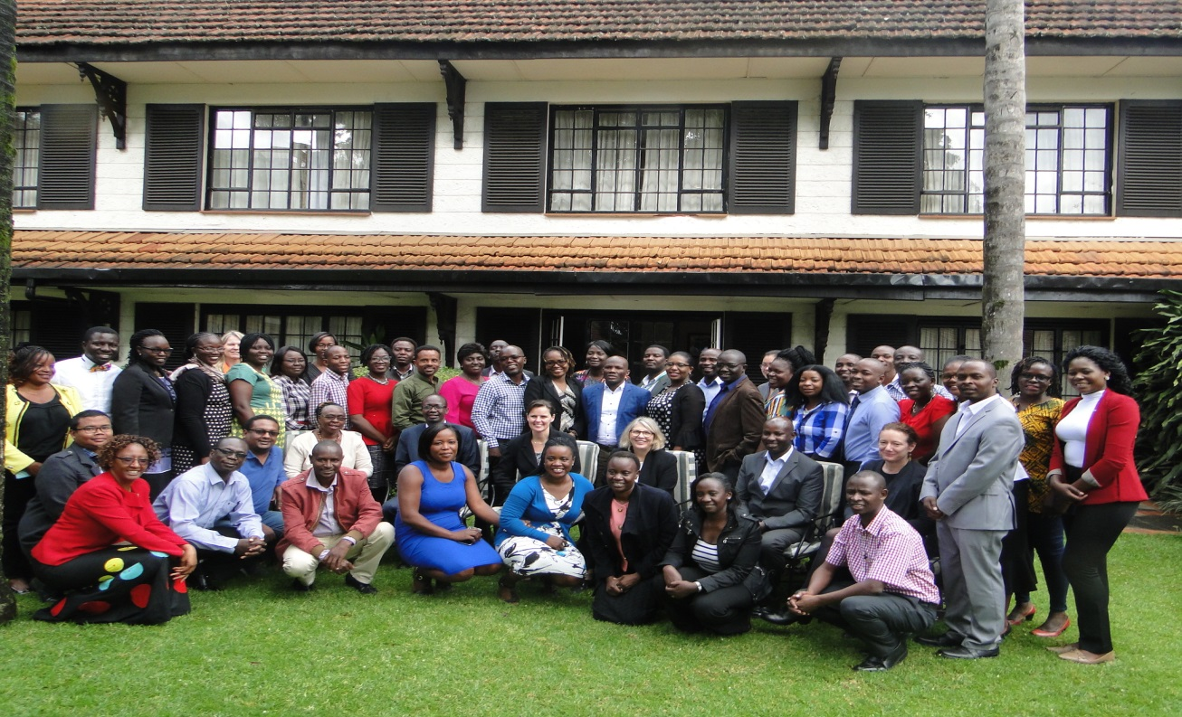

**FACULTY AGRCULTURE PARTICIPATION IN AUSTRALIA AWARDS AGRICULTURE ALUMNI WORKSHOP, 29TH NOVEMBER, 2018**

The Australia Awards Agriculture Alumni workshop was held at the Southern Sun Mayfair Hotel, Nairobi on 29th November 2018. This workshop was held alongside the ongoing short course on increasing the Development Impact of Agricultural Research in Africa. The workshop brought together 15 local Australia Awards Alumni (PhD, Masters and Short Courses) based in Kenya, the 29 participants currently undertaking the short course, agricultural academics presenting in the program from Australia and Kenya, representatives of the Australia Awards management and the staff from the Australia High Commission.

The workshop was opened by the Australian High Commissioner to Kenya and Tanzania H.E Alison Chartres, and attended by the coordinators of the short course programme; Prof. Robyn McConchie and Emma Walters from the University of Sydney and Prof. George Cheminingw’a and Prof. Florence Olubayo from the University of Nairobi.

The objectives of the workshop were to:

* Showcase successful case studies in agriculture and food security
* Promote collaboration among African researchers, and cross Africa-Australia research
* Identify major challenges and solutions for future alumni working in African-Australian agricultural research
* Promote the activities of Australia Awards Africa
* Increase networks for alumni of the Australia Awards Africa Short Course in IDIAR

|  |  |
| --- | --- |
| C:\Users\ALPHA\Desktop\IDIAR\Field trip photos\Alumni workshop\DSC01417.JPG | C:\Users\ALPHA\Desktop\IDIAR\Field trip photos\Alumni workshop\DSC01458.JPG |
| HE. Alison Chartres: Australian High Commissioner to Kenya and Tanzania | Prof. George Cheminingw’a: Dean Faculty of Agriculture |

The Australia Awards alumni shared how have implemented their Reintegration Action Plan (RAP) and how they addressed the challenges thereof. The sharing by the alumni encouraged the current participants to appreciate the importance of the training they have received and the contribution it will make to agriculture in their countries. Very useful engaging discussions and the networking followed thereafter over lunch.