FACULTY PARTICIPATION IN AUSTRALIA AWARDS WRITING FOR SCIENTIFIC PUBLICATION TRAINING, 30TH NOVEMBER, 2018
The Australia Awards writing for scientific publication training was held at the Southern Sun Mayfair Hotel, Nairobi on 30th November 2018. This training was held as part of the ongoing short course on increasing the Development Impact of Agricultural Research in Africa. Members of staff and several PhD students from different departments in the faculty of Agriculture, University of Nairobi attended the training alongside the 29 participants currently undertaking the November 2018(IDIAR) Short course.
The training was conducted by Prof. Robyn McConchie from the University of Sydney, a Professor of Horticulture and the Director ARC ITTC Food Safety in Fresh Produce. Prof. McConchie is also the Theme Leader of Quality Food at the Sydney Institute of Agriculture and Board Member Fresh Produce Safety Centre, School of Life and Environmental Sciences, Faculty of Science, in the University of Sydney. A total of 10 participants were invited from the Faculty of Agriculture. The six members of staff and Ph.d students who attended appreciated the training and the networking thereafter. Prof. Robyn McConchie runs the Australia Awards short Course on ‘increasing the development impact of Agricultural Research in Africa’ in collaboration with Prof. Florence Olubayo from the Department of Plant Science and Crop Protection.
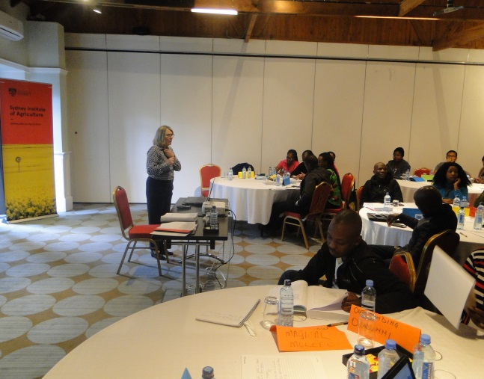 | 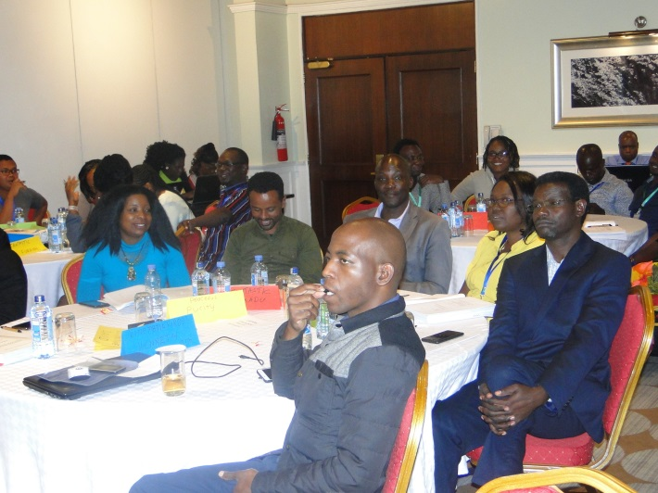
Prof. Robin McConchie training on scientific writing | UON CAVs staff among the participants

