

UNIVERSITY OF NAIROBI
FACULTY OF AGRICULTURE
DEPARTMENT OF PLANT SCIENCE AND CROP PROTECTION

SEED SYSTEMS TRAINING COURSE
6th – 17th October 2025
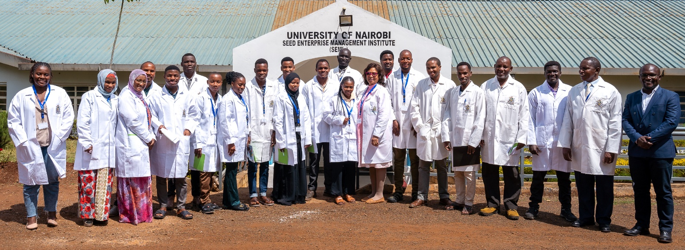

SEMIs Facility, Department of Plant Science and Crop Protection
Faculty of Agriculture, the University of Nairobi

Trainer Institution:  Department of Plant Science and Crop Protection  Faculty of Agriculture, University of Nairobi | Funded By:  Africa Enterprise Challenge Fund (AECF)  West End Towers, Kajata Road  P.O. Box 1996-00606, Westlands, Nairobi, Kenya

The Department of Plant Science and Crop Protection, Faculty of Agriculture, University of Nairobi conducted a two-week training from 6th to 17th October, 2025 at SEMIs to enhance the knowledge and skills of 19 seed production staff from Tanzania, South Sudan and Nigeria. The training was funded by Africa Enterprise Challenge Fund (AECF).
The main focus of the training will be on the following aspects of seed production and enterprise management:
- Seed Production;
- Seed Quality Assurance;
- Seed Drying, Processing and Storage;
- Seed marketing;
- Seed business management.

The objectives of the training course were:
- To enhance knowledge and practical skills of the participants on:
- To enhance knowledge and practical skills of the participants on:
- To build the capacity of the participants on:
- To improve the participants to capacity on:
- To enhance the participants knowledge on:
The course was facilitated by a total of 12 professionals with diverse expertise in seed production, seed quality assurance, seed processing, marketing and seed business management. The facilitators were from the Faculty Business and Management Sciences, Faculty of Agriculture, Faculty of Engineering, Kenya Plant Health Inspectorate Service (KEPHIS) and Seed Trade Association of Kenya (STAK).
